NAME: MALLIK R

Reg No : 211039017

1. Assume a 32-bit number in 40000004H. Add nibble4 and nibble0 and store the result in 4000000CH.

AREA PROGRAM, CODE, READONLY

ENTRY

Main

LDR R0,value ;load the value to the register R0

LDR R1,[R0] ;load the content of R0 to R1 register

LDR R2,mask1 ;load the value of to R2 register

AND R3,R1,R2 ;mask the value of R1 using R2 and store it in R3 register

MOV R4,R1,LSR #16 ;logical right shift 16 bit of R1 data and move it to R4 register

AND R5,R4,R2 ;mask the value of R4 using R2 and store it in R5 register

ADD R6,R5,R3 ;add the registers R5 and R3 and store it in R6 register

LDR R7,result ;load the value of result to R7 register

STR R6,[R7] ;store the data present in R6 register to the address of R7 register

SVC &11

value DCD &40000004

mask1 DCD &0000000F

result DCD &40000000

END

Result:

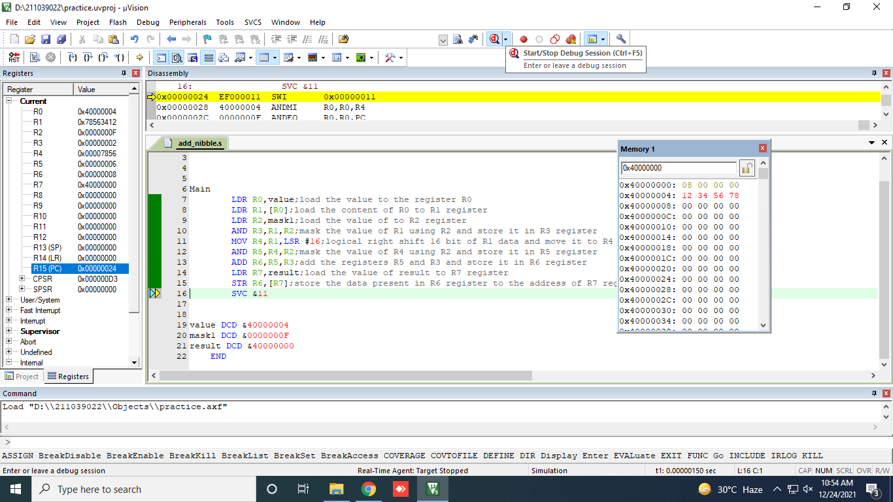

2)  Consider an array of number present from 40000000H. Add only if the numbers are positive. 40000000H has the count of the array.

AREA ADD_ARRAY,CODE,READONLY  
ENTRY  
MAIN  
LDR R0,TABLE ; In the table first value is count followed by array elements  
LDR R2,[R0] ;Load the count  
EOR R3,R3,R3 ;Clear Register R3 for storing sum of positive elements  
LOOP  
CMP R2,#0 ; Compare count with Zero  
BEQ DONE  
LDR R1,[R0,#4]! ;Load the array elements to R1 register  
CMP R1,#0 ;Compare R1 register content with 0  
BMI LOOP1 ;If the number is negative then Branch to Loop1 and  
;decrement the count  
;BMI - Branch if minus ; It checks the Negative Flag if it is set Branch to Loop1  
ADD R3,R3,R1 ;If the number is positive Add it with R3 register content  
SUB R2,R2,#1 ;Decrement the count  
B LOOP  
LOOP1  
SUB R2,R2,#1  
CMP R2,#0  
BEQ DONE  
BNE LOOP  
DONE LDR R4,RESULT  
STR R3,[R4] ;Load the Result in R3 to desired location  
STOP B STOP  
  
TABLE DCD &40000000  
RESULT DCD &4000003C  
END

Result:

